Provider Profile Test Case:
ITSDT-293: Test Bento Administration Component UI ITSDT-285
Purpose: To test two component features added in sub-tasks that allow for export of Bento button and the checkbox
Tester Name: Michelle-Elizabeth Valle  Date(s) of Test: 10/16/2019  Tested on (test environment/platform): functional test in test environment with IP address 10.194.52.203 in Google Chrome. | Prerequisites for this test: Need to be behind a Booz Allen firewall or have VPN connection through f-5 vpn client
Software Versions: IT Strategy Diagnostic Tool (test environment)
Browser(s): Chrome
 | Required Configuration: admin credentials needed: admin@admin, password
NOTES and RESULTS: PASS

TEST SCRIPT STEPS/RESULTS
STEP | TEST STEP/INPUT | EXPECTED RESULTS | ACTUAL RESULTS | PASS/FAIL
 | Connect to Big-IP Edge Client | Connected | Connected | PASS
 | Open browser and type in 10.194.52.203 | User navigates to the Diagnostic Tool test environment log in page | 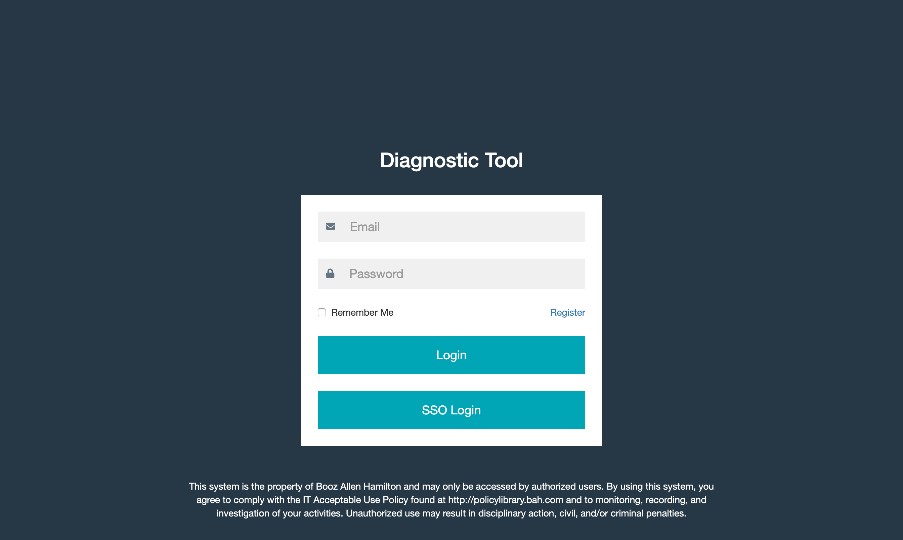 | PASS
 | Enter username and password and click enter | User navigates to the Diagnostic Tool landing page | 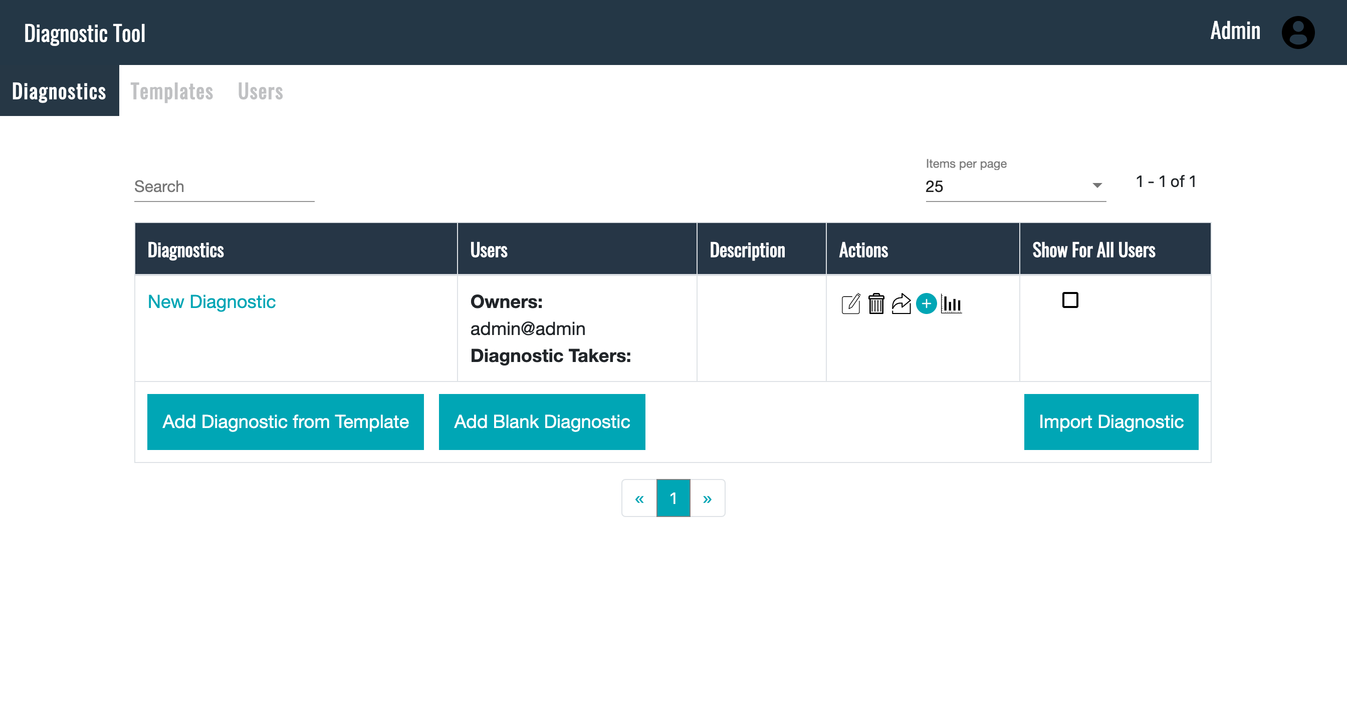 | PASS
 | On landing page, click on “Import Diagnostic” button and import .json file “Bento Diagnostic (1).json” | User selects a previously saved diagnostic and loads it to the tool. | 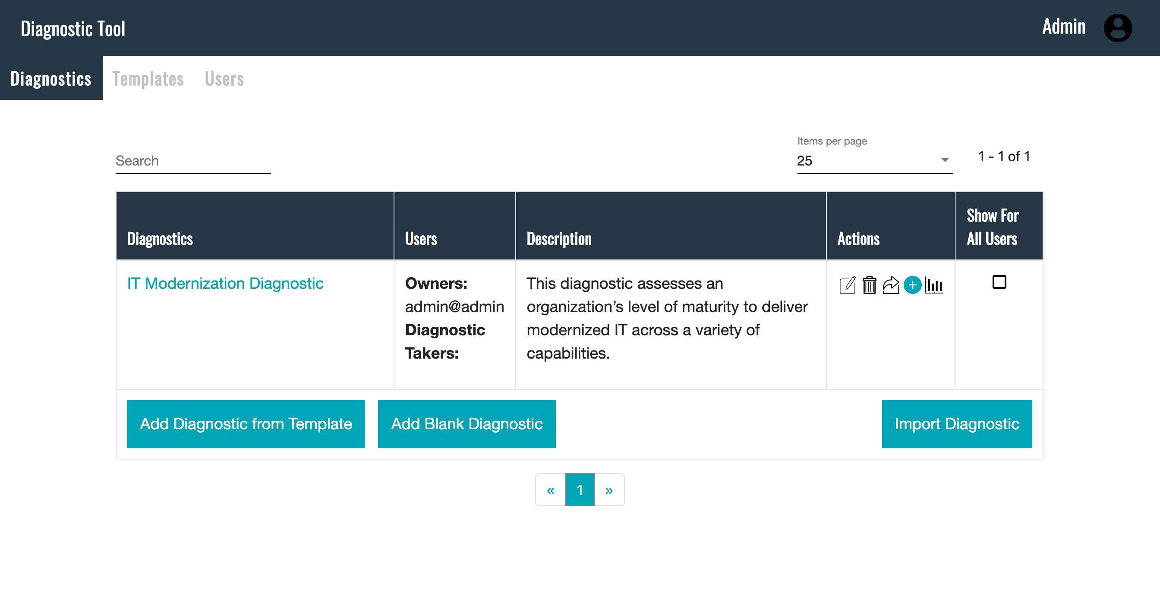 | PASS
 | Click on edit diagnostic icon in the Actions column in the “Bento Diagnostic” row | User clicks on icon and navigates to the edit page. | 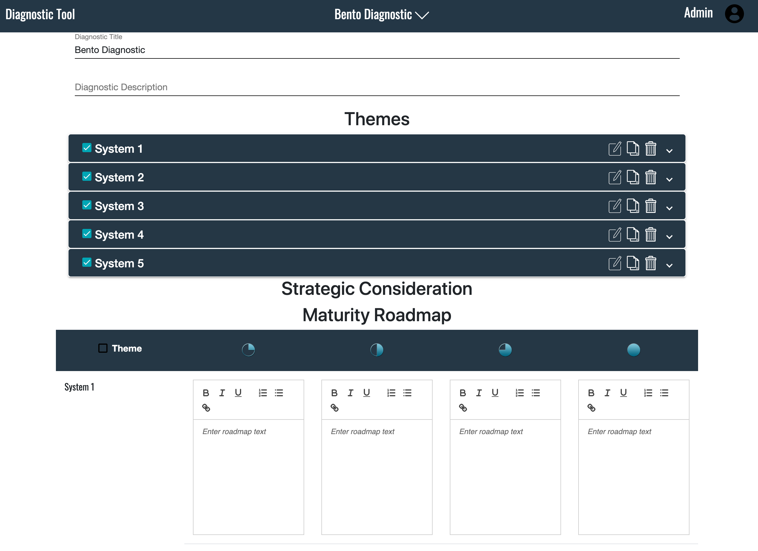 | PASS
 | Hover over the “Bento Diagnostic” chevron | User sees a popup with a checkbox and the text “Bento Integration” | 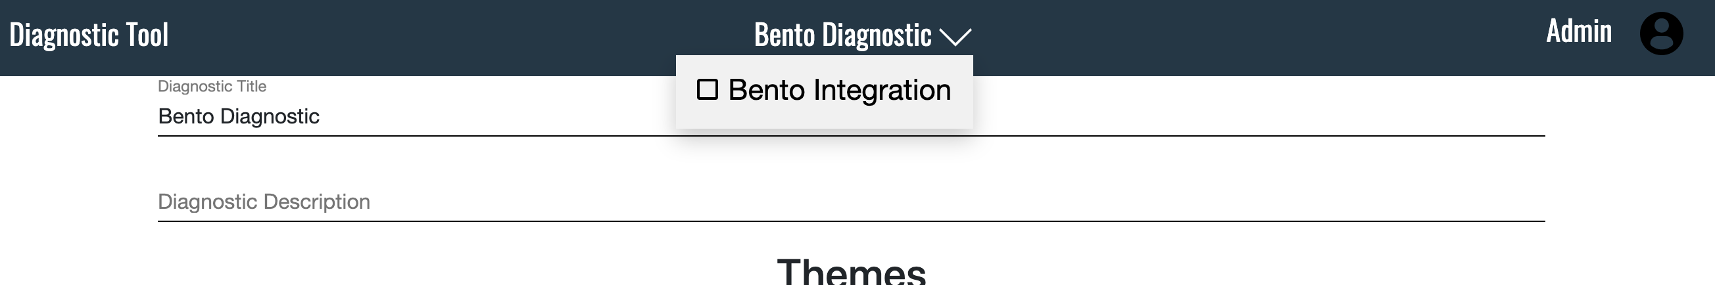 | PASS
 | Click on the checkbox | User clicks on checkbox and sees a check marked in the box | 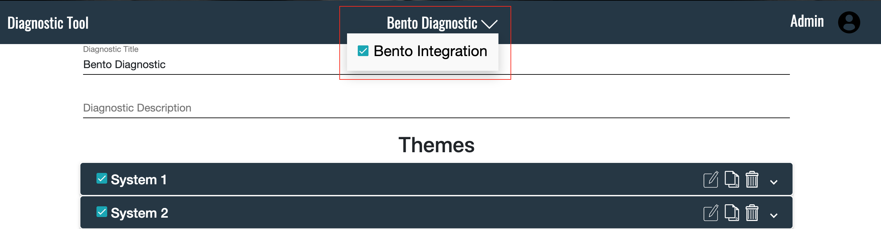 | PASS
 | Log out as a sys admin and log in as a diagnostic administrator using the credentials: test@test.com, password | User navigates to Diagnostic Tool home page. | 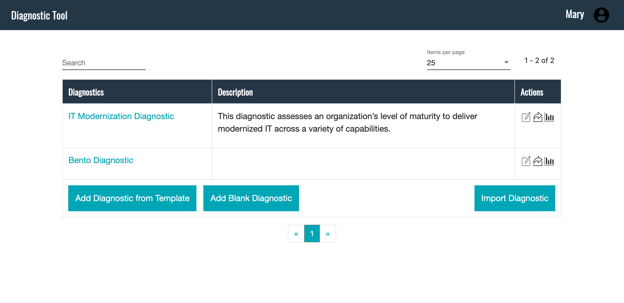 | PASS
 | Click on the link to the Bento Diagnostic | User navigates to the Bento Diagnostic page | 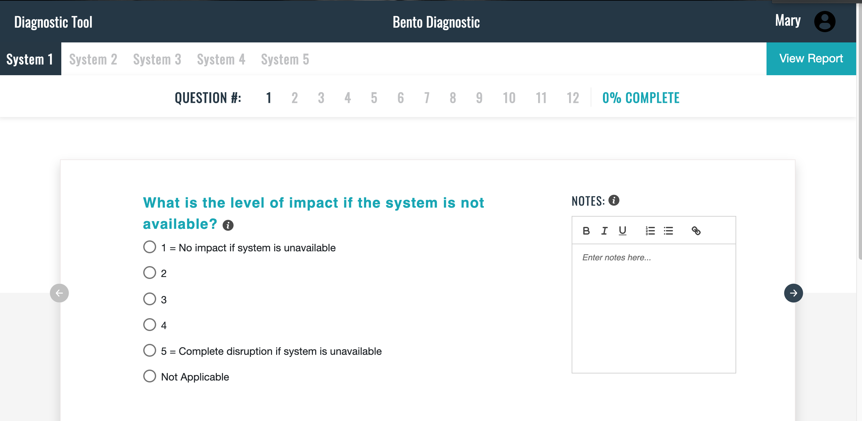 | PASS
 | Click on the “View Report” button | User navigates to the report page | 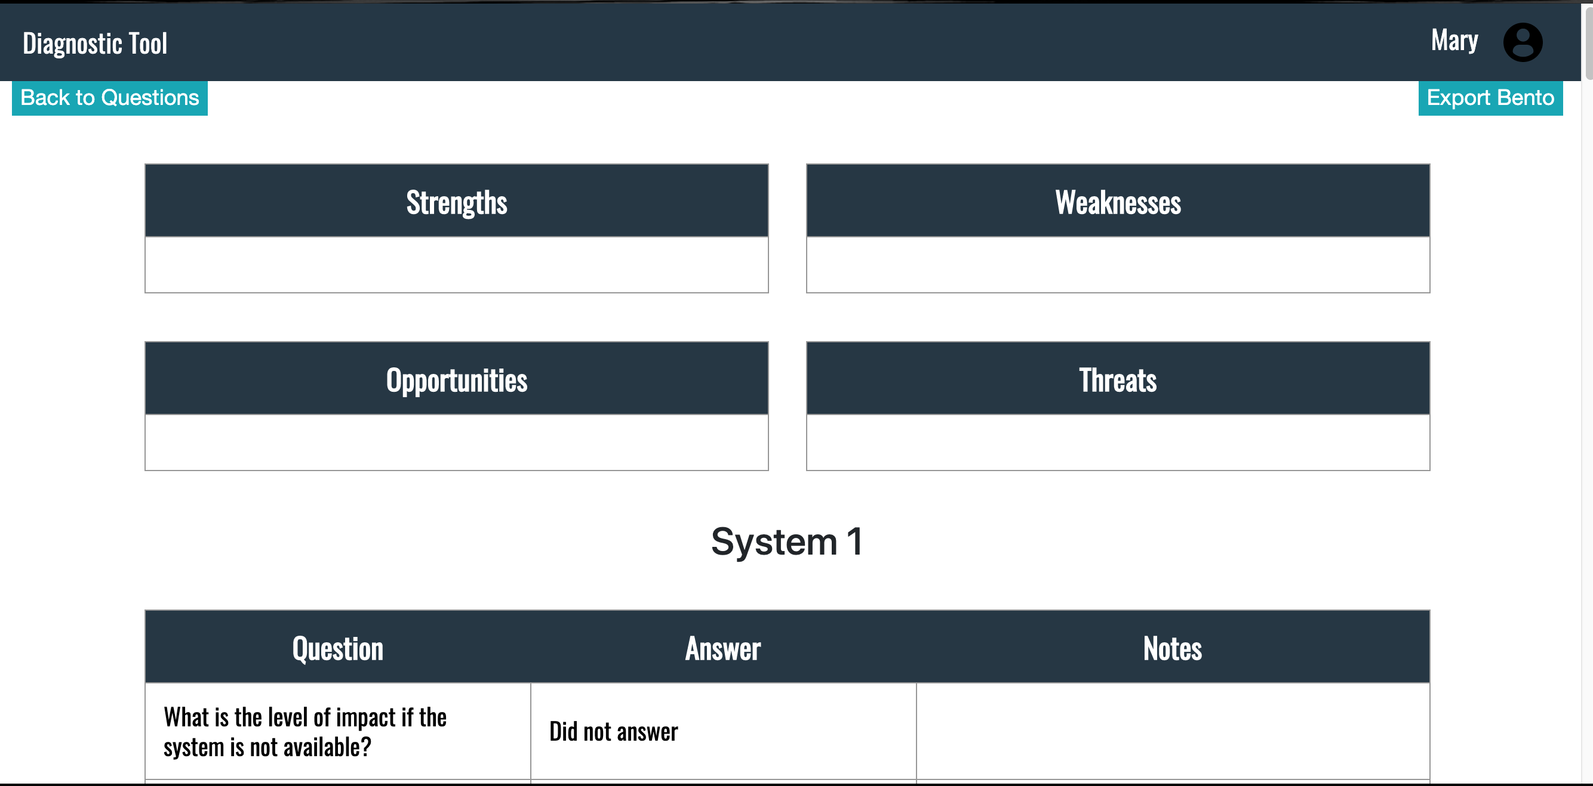 | PASS
 | Click on “Export Bento” button | Download of a .json file takes place | File is downloaded | PASS

